Google Adsmob for TriplePoker : Rise
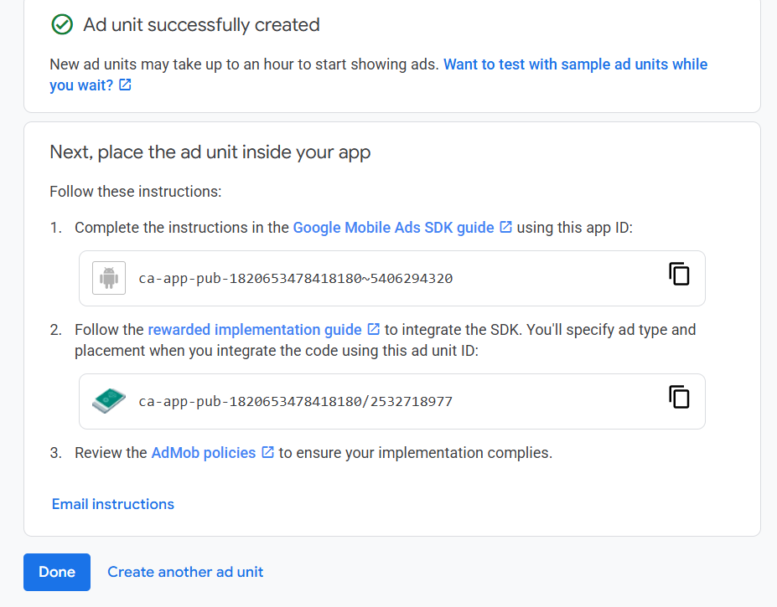
ca-app-pub-1820653478418180~5406294320
ca-app-pub-1820653478418180/2532718977

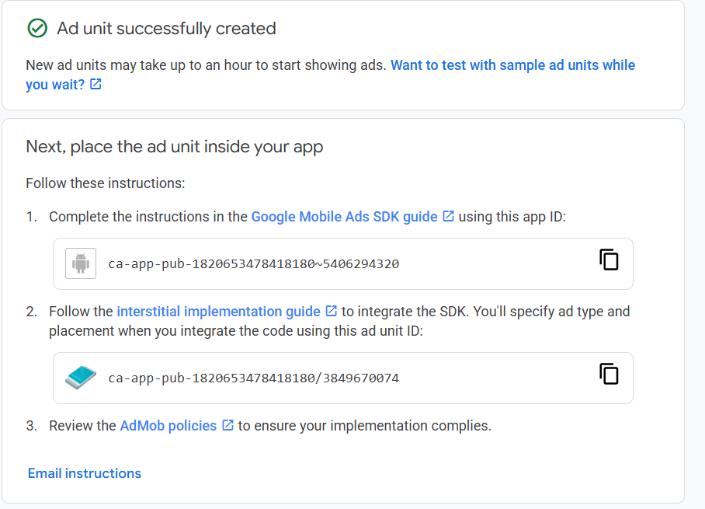
ca-app-pub-1820653478418180~5406294320
ca-app-pub-1820653478418180/3849670074

